## REGRES LINEAR SEDERHANA

* Fungsi untuk import data (excel)

library(readxl)  
data <-read_excel("C:/Users/Lenovo/Downloads/data.xlsx")  
data$IPK <-as.numeric(data$IPK)

* Fungsiuntukmendeskripsikan data

summary(data)

## Nama Jenis kelamin Usia Prodi   
## Length:127 Min. :0.0000 Min. :17.00 Min. :0.00   
## Class :character 1st Qu.:0.0000 1st Qu.:20.00 1st Qu.:0.00   
## Mode :character Median :0.0000 Median :20.00 Median :2.00   
## Mean :0.4724 Mean :20.72 Mean :2.52   
## 3rd Qu.:1.0000 3rd Qu.:21.50 3rd Qu.:3.50   
## Max. :1.0000 Max. :43.00 Max. :9.00   
## Kesesuaian prodi Pembiayaan Kota asal Kos   
## Min. :0.0000 Min. :0.0000 Min. :0.0000 Min. :0.0000   
## 1st Qu.:0.0000 1st Qu.:0.0000 1st Qu.:0.0000 1st Qu.:1.0000   
## Median :1.0000 Median :0.0000 Median :0.0000 Median :1.0000   
## Mean :0.5669 Mean :0.5984 Mean :0.7953 Mean :0.7638   
## 3rd Qu.:1.0000 3rd Qu.:1.0000 3rd Qu.:1.0000 3rd Qu.:1.0000   
## Max. :1.0000 Max. :2.0000 Max. :4.0000 Max. :1.0000   
## Jam belajar Kendaraan IPK   
## Min. :0.000 Min. :1.000 Min. :2.100   
## 1st Qu.:1.000 1st Qu.:1.000 1st Qu.:3.250   
## Median :2.000 Median :1.000 Median :3.500   
## Mean :1.551 Mean :1.299 Mean :3.460   
## 3rd Qu.:2.000 3rd Qu.:1.000 3rd Qu.:3.715   
## Max. :3.000 Max. :3.000 Max. :4.000

* Fungsi untuk memvisualisasikan data

par(mfrow=c(2,2))  
hist(data$`IPK`,main="Histogram IPK",xlab="IPK", las=1)  
hist(data$`Jam belajar`, main ="Histogram Lama Belajar",  
xlab="Lama Belajar", las=1)  
boxplot(data$`Jam belajar`, data$`IPK`,  
main="Boxplot IPK vs Lama Belajar",  
names=c("Lama Belajar","IPK"))  
plot(data$`Jam belajar`, data$`IPK`, main="Scatterplot IPK vs Lama Belajar",  
xlab="Lama Belajar",  
ylab="IPK", pch=15,las=1)  
abline(lm(data$`IPK`~data$`Jam belajar`),col="red")

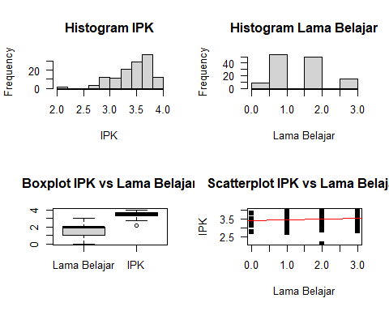

* Fungsi untuk mengetahui nilai korelasi antar hubungan

waktu_belajar = data$`Jam belajar`  
IPK=data$`IPK`  
cor.test(waktu_belajar, IPK)

##   
## Pearson's product-moment correlation  
##   
## data: waktu_belajar and IPK  
## t = 1.4004, df = 125, p-value = 0.1639  
## alternative hypothesis: true correlation is not equal to 0  
## 95 percent confidence interval:  
## -0.05103845 0.29216994  
## sample estimates:  
## cor   
## 0.1242813

* Fungsi untuk melihat nilai variabilitas antar hubungan data

Model_Regresi =summary(lm(IPK~waktu_belajar))  
Model_Regresi

##   
## Call:  
## lm(formula = IPK ~ waktu_belajar)  
##   
## Residuals:  
## Min 1Q Median 3Q Max   
## -1.3831 -0.1826 0.0679 0.2424 0.5169   
##   
## Coefficients:  
## Estimate Std. Error t value Pr(>|t|)   
## (Intercept) 3.38106 0.06346 53.28 <2e-16 ***  
## waktu_belajar 0.05104 0.03645 1.40 0.164   
## ---  
## Signif. codes: 0 '***' 0.001 '**' 0.01 '*' 0.05 '.' 0.1 ' ' 1  
##   
## Residual standard error: 0.3248 on 125 degrees of freedom  
## Multiple R-squared: 0.01545, Adjusted R-squared: 0.007569   
## F-statistic: 1.961 on 1 and 125 DF, p-value: 0.1639